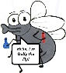

Lyng Primary School Knowledge Organiser

Topic: | Mixtures and separating: What makes a mixture and how do you separate them? | Year 5 | Autumn 1

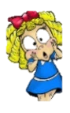
What should I already know?
To know that property refers to how a material can be described.
To describe the physical properties of a variety of everyday materials.
To know why objects are made from particular materials and to give examples of their suitability.
To know that a property of a solid is that it keeps its shape unless a force is applied to it.
To know that a property of a liquid can flow freely and take on the shape of a container.
To know that a property of a gas does not have a fixed shape and can escape from an unsealed container.
Notable scientists
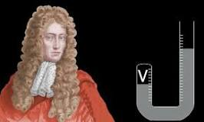
Robert Boyle
1627–1691
What Step On and Goldilocks words will I use?
Spelling | Definition
Variable | A factor that can be changed
Dissolve | Become incorporated into the liquid to form a solution
Evaporation | Process of turning from a liquid to a vapour
Insoluble | Incapable of being dissolved
Particle | Smallest amount
Sieving | Filter out larger parts of material
Solution | A liquid mixture in which substances have dissolved
Crystallising | To form a crystal
Filtering | Pass through a device to remove unwanted material
Soluble | Able to dissolve in liquid
Mixture | A substance made by mixing other substances together

Investigate!
- Make 5 different mixtures:
- containing two solid substances
- containing three different coloured substances
- containing three substances that are the same colour
- containing a liquid and a solid
- containing a magnetic material and another solid substance.
- Separate mixtures by sieving
- Separate mixtures by filtering
- Mix to make solutions
- Carry out a comparative test to investigate dissolving sugar.
- Evaporation over time – salt in lids.

- Observe and describe the size of the pieces which pass through or are trapped.
- Line them up from smallest to largest
- Draw and annotate their own diagram (in their books) that explains how each separation can be used to separate mixtures of solids with different sized particles.

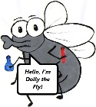
What will I know by the end of the unit?

What are mixtures? | 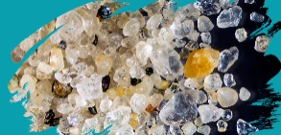  They are made up of two or more substances.  They all have the properties of their component substances.  They can all be separated.
What is sieving? | 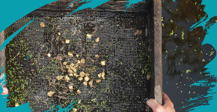  It is the physical process of particle removal.  Particles cannot pass through holes that are smaller than themselves.  Holes are usually visible to the naked eye
What is filtering? | 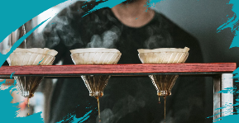  The physical process of particle removal.  Particles cannot pass through holes that are smaller than themselves.  Holes are very small and stop very small particles from passing through.
What are solutions? |   A mixture of two or more substances that stays evenly mixed.  The substances are combined to make a solution but they do not change into new substances.
What is dissolving? | 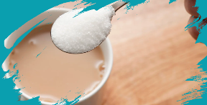  Some substances dissolve when mixed with liquids.  It may look like it has disappeared but it’s mixed and appears translucent
What is evaporation? |   The process of a liquid turning into a gas.  Due to increased energy of particles.  It is due to a liquid being heated.

Lyng Primary School Knowledge Organiser

Topic: | Science | Year 5  Forces | Autumn 1

- Which substance is not a mixture? | S |  | E
- Salt
- Sand
- Soil
- Seawater
4. which of these substances dissolves to make seawater? | S | E
- Sand
- Flour
- Salt
- Sugar
Explain how the process of sieving works | S | E
Use the words below to help you.

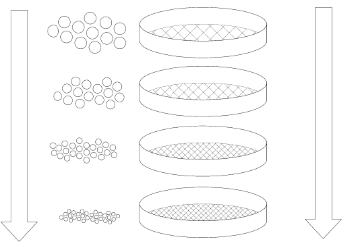
Solid-solid (different size particles)
Holes
Pass through
Largest to smallest
separate

2. Which method is best to separate flour and water? | S | E
- Sieving
- Magnetism
- Filtering
- Evaporation

3. What type of mixture does sieving separate? | S | E
- Liquid and liquid
- Solid and solid (different size particles)
- Solid and solid (same size particles)
- A solution

4. What process has to happen for a solution to be made? | S | E
- Evaporation
- Dissolving
- Crystallisation
- Stirring

